**SURVEY REPORT**

**ON**

**STUDENT LEARNING PREFERENCES**

Prepared for the S.E.E.S ’21 by:

Ifeakor Nnaemeka Praise

**Contents**

***Disclaimer***

***Acknowledgments***

***Preface***

***Limitations***

1. ***Survey questions, response and observations.***
2. ***Attending class, Learning on your own and Learning in class.***
3. ***Lecture preference and reading mode plot.***
4. ***Conclusion (Is there hope?).***

***Disclaimer***

The survey carried out has no official backing and hence cannot be used as evidence or as source for official or formal purposes. The insights obtained from the dataset do not directly in reality reflect the opinion of the analyst or the students that participated in the survey. The survey was carried out specifically for educational, analytical and exploratory purposes only.

***Acknowledgments***

This report would not have been possible without the responses contributed by the students who participated in the survey. My profound gratitude goes out to every single person who took the time to answer the survey questions genuinely.

I would also like to specially thank Arinze Owoh and Nwachukwu Godwin for assisting in the editing and preparation of the survey.

***Preface***

This is not a storybook or a life journal. It is a report and the goal of this section is to:

1. Explicitly explain the purpose of the survey.
2. Address the reader.

**Purpose of Survey**

As stated in the description of the survey, its purpose is to provide data for acquisition, analysis and visualization of quantitative and categorical data that can be used to further explore the preferred learning process of the S.E.E.S ‘21 set. It was conducted to obtain real values for specific questions which upon intermediate analysis would give room for insights and plausible postulations. These postulations can be regarded as contextual conclusions which are merely informative.

**To the Reader**

This is not a formal report. However, it is sequential by format. The visualizations used here are basic and hence require an elementary understanding of statistics to properly conceptualize the details. The report in itself is just an insightful summary of the technical analysis performed on the responses obtained from the survey with the use of python. In the real sense, these responses had to be cleaned and pre-processed before valuable insights could be drawn from them.

All charts and graphs were plotted using python with the help of standard libraries and dependencies. The tables and visuals shown in this report are snippets from my jupyter notebook (except for the Read-mode table which was obtained directly from Microsoft excel). I encourage you to go through the notebook after reading this report to see the flow of the analysis. The link to my github repository (where the notebook was uploaded) is available at the end of this report. For those who just want to read up the insights, I hope you find this report worthwhile.

***Limitations***

The only limitation faced was the number of responses. There were a total of 147 year 3 students at the time this survey was conducted. Out of 147 students, only 89 students filled the survey. This shortage of responses definitely limits the plausible insights that can be drawn from the values obtained. Thus this report is an attempt to infer logical conclusions from the 89 responses and to hopefully illuminate the general subject matter as discussed in the preface.

**I**

***Survey questions, response, and observations.***

A total of 15 questions were asked. Some questions required categorical answers (e.g., yes/no, classroom/online, grade 1 or 2 or 3 or 4 or 5), while others required definite answers (e.g., Name, Nationality) and explanations (e.g. reasons for a particular choice). The questions are as follows:

* Name (First name and Last name):
* Nationality:
* Name of secondary school:
* Mode of entry into University:
* Department:
* Did you skip primary 6?
* Did you skip SS3?
* Would you rather receive lectures online or in your classroom?
* State reason why you prefer either:
* Can you read a course and understand it without being taught by your lecturers?
* Select your preferred reading mode (select all that apply):
* On a scale of (1-5) grade your learning in class (university):
* If less than 3 give reasons:
* On a scale of (1-5) grade learning on your own:
* On a scale of (1-5) grade your attendance record in all classes:

The survey was conducted on the S.E.E.S ’21 set and it lasted from September 16th to September 30th. Do note that:

* Computer and electrical students share the same class.
* Both departments practically offer the same courses in year 3 and are lectured by the same lecturers (except for one or two courses).
* The total number of U.T.M.E electrical students = 67.
* The total number of D.E electrical students = 32.
* Total electrical students = 67 + 32 = 99.
* The total number of U.T.M.E computer students = 31.
* The total number of D.E computer students = 17.
* Total computer students = 17 + 31 = 48

**Below represents the total responses obtained from the survey and the pie-chart visualization.**

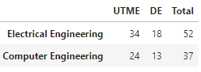

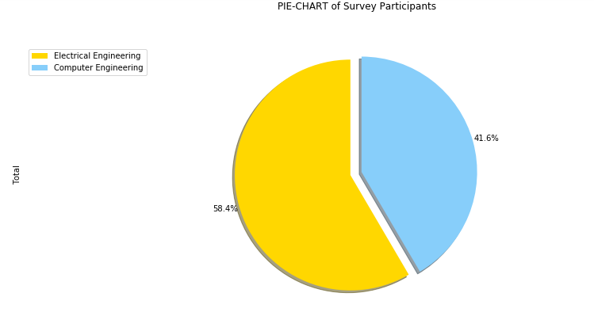

There is no arguing which department outnumbers which, but can we really say that more electrical students participated in the survey? Well, here are the tables and visuals for those that filled or did not fill for both departments.

**ELECTRICAL ENGINEERING**

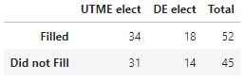

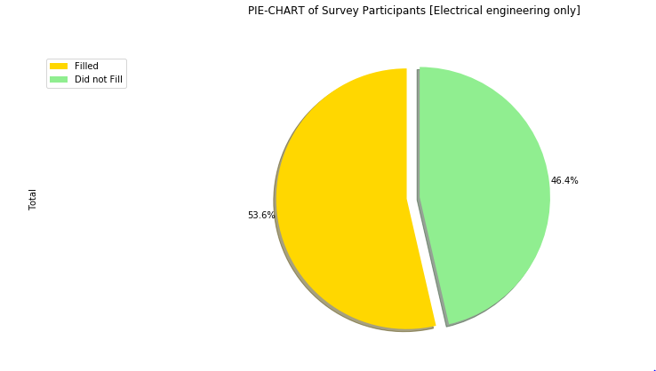

**COMPUTER ENGINEERING**

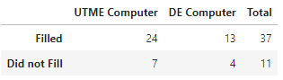

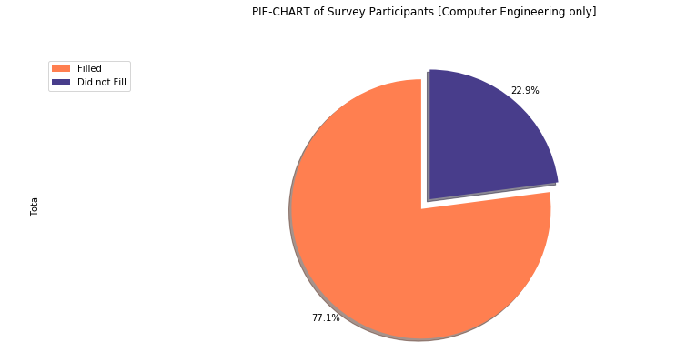

Well from the visuals, it is obvious which department participated more in the survey. The pie chart clearly distinguishes both departments. More than 77% of computer students filled the survey. This is greater than the 53.6% of electrical students that participated in the exercise.

This makes the data obtained from the computer students more tangible to work with because it encompasses the response from a significant majority of all the computer engineering students. The exploration of responses from computer students however is not cited in this report. Although it is not cited here, it should be noted that the same approach used in this report was employed in the analysis of the responses of computer students and there is no much difference in the insights obtained. The computer analysis can be found in my repository shared at the end of this report.

Hence this report contains the insights obtained from the total set of participants as a whole and not by department. In other words, it tries to explain what the 89 survey participants are saying.

**II**

***Attending class, Learning on your own and Learning in class.***

Conventionally the idea is that you attend classes, learn in those classes and finally use the pre-obtained knowledge from your class experience to learn on your own (or at least that is the summary of how the patriarchs of pedagogy and education would describe the ideal learning process for a student whose aim is to excel in academia). If that is true, then physical interaction of teacher and student is the building block of adequate learning and understanding in the classroom –which of course every literate would give as one of the merits of attending classes.

However, the ideal usually only exists as an idea due to the fact that pragmatism would always object in reality. How is this relevant? Take a look at this snippet:

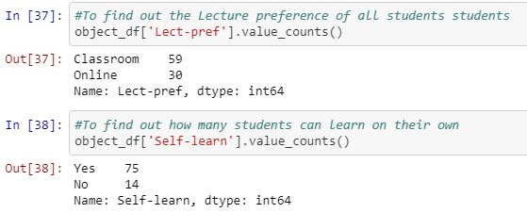

Now the first line of code (In [37]) is a data frame invoking a method to display the number of students that picked their preferred learning mode as classroom or online. The second line (In [38]) is also a data frame invoking a method to display the number of student who picked yes or no when asked if they can learn on their own or not. Now the block of code is not the point here. It’s the output we are concerned with i.e. 59 students prefer to learn in the classroom while 30 prefer to learn online and 75 students can learn on their own while 14 students cannot.

If you notice from the outputs displayed in the previous page, although more people prefer to learn in the classroom than via online tutoring, more people claim to be able to learn on their own without class tutoring. In fact, more than 80% of the students that participated in the survey filled in 'Yes' which clearly beats the 66% that prefer to learn in the classroom.

Now if that is true, then it is imperative to know how the students graded their classroom learning experience and self learning experience. The grading scheme ranged from 1 to 5 in which a 3 would represent an average grade.

Below represents the visuals obtained from the analysis of self learning and learning in class.

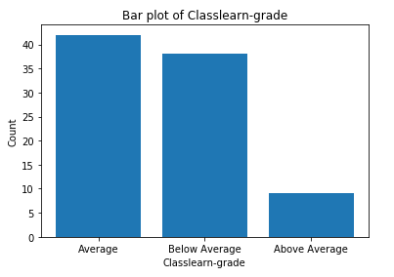

Notice how less than 10 out of 89 students graded their learning in class above average.

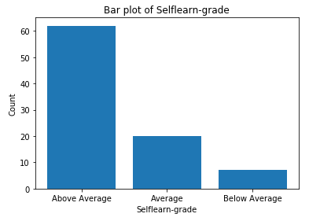

Also notice how more than 60 people graded their self learning above average.

Even though we have an idea of what is going on in the self learning and class learning plots, it is expedient to conceptualize the visuals into one plot that generalizes the analysis of attending classes, learning on your own and learning in class. By doing it this way, we have a model of what the participants are really saying. The metric used is the mean of all the responses pertaining to each particular question. The table is below:

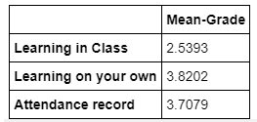

The plot of the mean of the learning grades of all participant.

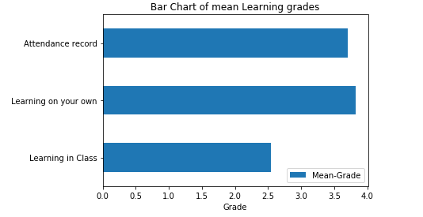

To postulate, the plot tells us that attending classes are a pure waste of time. I can conclude on that insight because the plot above indicates that based on the grades recorded, the participants clearly attend more classes than they learn in them. It is pretty tempting and intuitive to conclude initially from the bar plots in the previous page that students don’t learn as much in class as they do on their own and we would still be right anyway, but the mean plot is more of a statistical measure and fortunately, it postulates the same thing.

Now the question is: ‘Why was learning in class so poorly graded?’ Hopefully the next section can provide some answers

**III**

***Lecture preference and reading mode plot.***

If we are to try and explain the possible reasons for the poor class learning grades, the lecture preference and class learning grades of the participants have to be explored with respect to the reasons given for the choices made. If you recall from the first section of this report, some part of the survey required students to:

1. State if they preferred receiving lectures online or in the classroom and give their reasons.
2. State the reasons for grading their learning in class a score less than 3.

After cleaning the responses obtained, it was observed that 37 students graded less than 3, while 28 students chose online as their preferred platform for receiving lectures. These values, though a minority, seems significant. Now to clearly define the issue, I made use of a word cloud. A word cloud displays a visualization of consistent words used in a string. The more a word is used, the bigger the word is in the cloud.

The main reason why anyone would prefer to learn in the classroom is due to the physical interaction of students and lecturers. In other words, it is easier to ask questions, get answers instantly and learn from questions asked by other students. It would be informative to know why 28 students prefer to learn online.

**Below is a word cloud describing the reasons students gave for preferring online.**

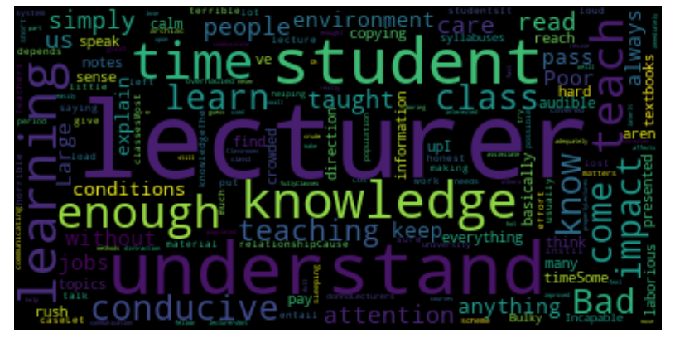

The word cloud helps to give a generalized reason why students prefer online lectures. If we are to identify the top 7 words, then that would be ***lecturer, understand, learning, knowledge, time, student, and enough***. However, the most consistent word used is ***lecturer.*** This means the kind of lecturer influenced the choice made by students who prefer to learn online.

What of the reasons given by 37 students that graded their learning less than 3? Is it possible to find a consistency in the words used if we are to generate a word cloud for them as well? In other words, will the reasons for grading their learning less than 3 be similar to the reasons given for preferring online lectures? If there is, then we can definitely postulate some valuable insights.

**Below is the word cloud generated from the reasons given for the grades less than 3.**

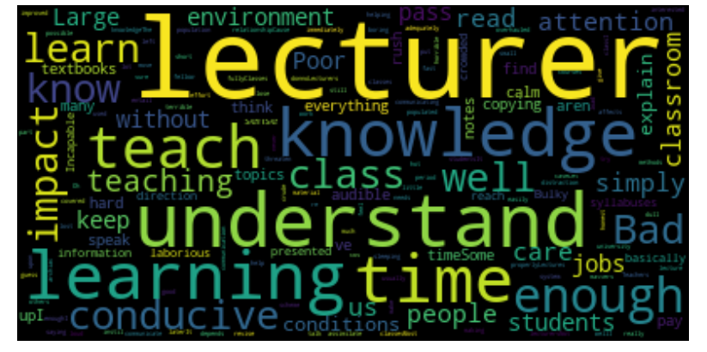

Well one particular word is boldly displayed in the different word clouds. This word is consistent and definitely screams two things:

1. The kind of lecturer is the main reason why 37 participants graded their class learning less than 3.
2. The kind of lecturer is also the main reason why 28 participants prefer to learn **online**.

The word cloud above also enables us to postulate that the **Lecturers** may not be doing their job of imparting **knowledge** well **enough** because there is not **enough time** to **learn** in class, the **environment** is not **conducive enough** and there is something **bad** about the **classroom** experience. You can confirm by just looking at the consistent words used.

Since it is obvious that a significant amount of students are not impressed by the system they are confined to, it is expedient to therefore know how all students cope with it. The read mode plot visualizes the methods students employ in order to gain understanding of some sort. The table below is pivotal in nature and it describes the responses obtained from all participants. The subsequent bar plot analyses the table visually.

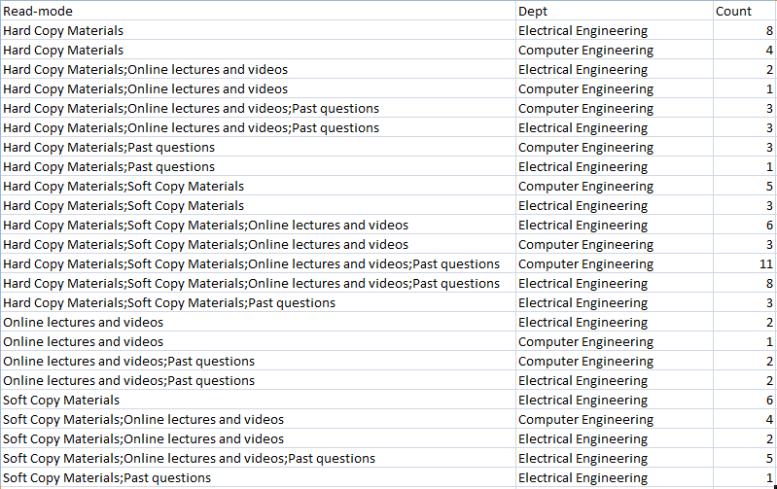

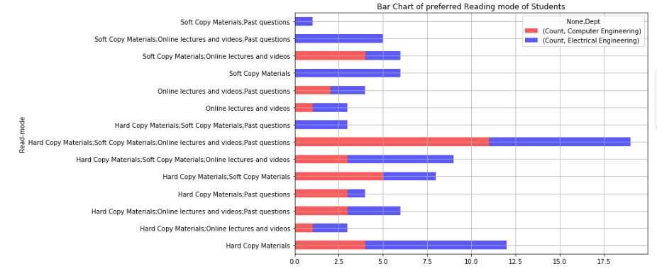**Bar plot of preferred reading mode of students.**

The visual above is stacked because of the nature of the table used to plot it. It had to incorporate both departments and the frequency of the choice of 14 reading modes/methods. The highest stack of course is the 7th label on the y-axis in ascending order.

**IV**

***Conclusion (Is there hope?)***

The conclusion from this survey according to the responses obtained and analysis performed evolved from being intuitive to being definite. It is without doubt that students are having a hard time learning in class and the most consistent words used in the several reasons they gave indicates the problem. The lecturer and classroom learning experience is the problem. So we have been able to analyze responses from students to infer the problem. What happens next?

Well, that question is for both the analyst and the S.E.E.S ’21 set to answer. For the analyst it seems pretty straightforward. Bring more data and let’s find more consistencies. If we can find a lot more consistencies and probably apply machine learning to even predict possible outcomes, then the probability of being heard would sky-rocket. The right people can be met and a restructuring process can be implemented which would favor not only this set, but other sets to come. However, how many students are willing to provide this necessary information? How many students are willing to provide a record of their academic profiles for analysis in order to visualize the obvious trend of poor performances of students? How many students are even in support of this report?

There would always be hope. It just depends on what the set is willing to do about it. On this note, I conclude by sharing a link to my [github repository](https://github.com/Nachi1999/Literate-carnival.git) lmao!